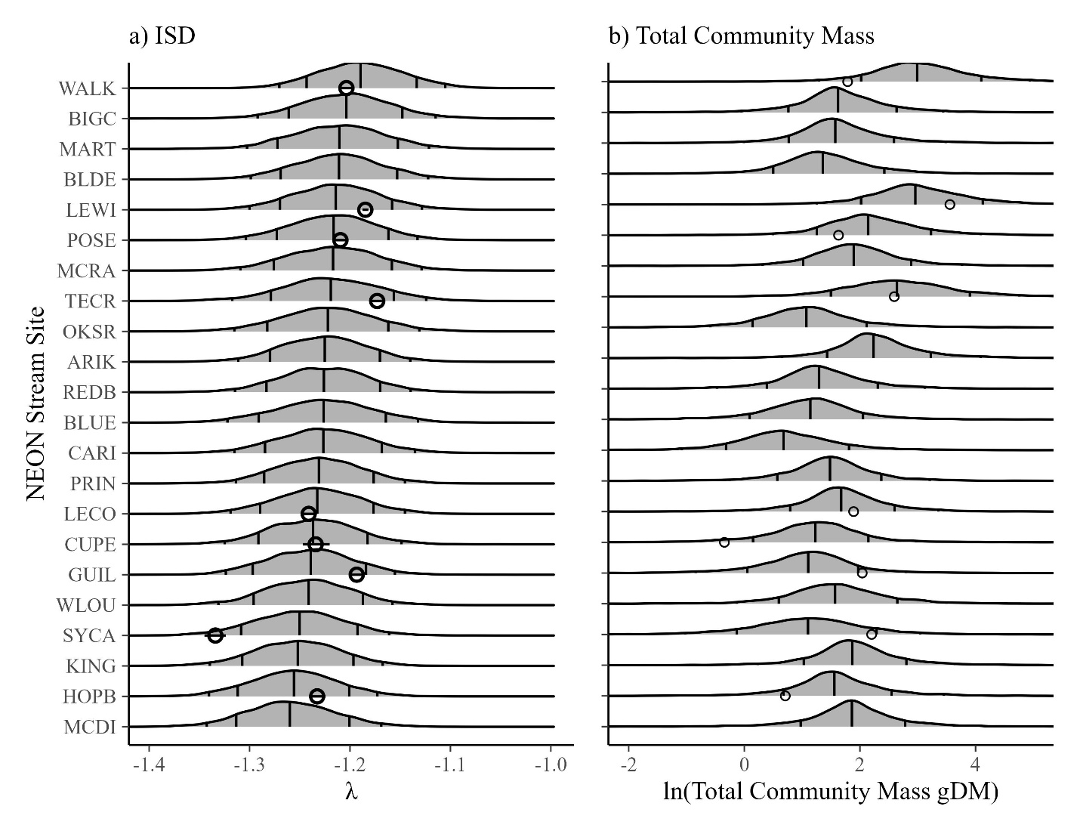

Figure X. Comparing forecasts (densities0 to future collected samples (dots). The densities show posterior predictions of a) lambda or b) natural-log of total community mass based on models using body sizes collected from 2016 through 2021. Vertical lines show the median, 80% and 95% quantiles (95% quantiles are small). Dots show the lambda or biomass values from samples collected in 2022, along with their 95% CrI (for lambda). All samples are within the 95% prediction intervals of the predictions, and 8/9 samples are within the 90% intervals.